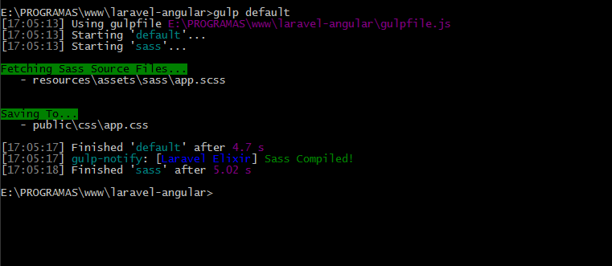

gulp.task(**'watch-dev'**, **function**(){  
 ***liveReload***.listen();  
 gulp.start(**'copy-styles'**,**'copy-scripts'**);  
 gulp.watch(***config***.**assets_path** + **'/**'**, [**'copy-styles'**, **'copy-scripts'**]);  
});

